**FIT – Barcelona, Madrid, Lisbon**

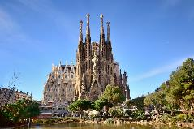 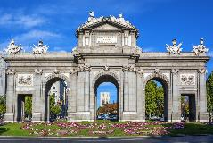 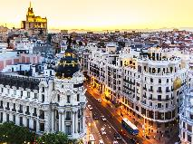 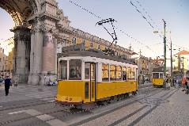

**day 1 Barcelona**

**private transfer** from Barcelona airport to the hotel in the city.

**leisure time** to discover the city. shopping could be your first option, you could watch a football game or enjoy a traditional flamenco show.

overnight at hotel in Barcelona.

**day 2 Barcelona**

breakfast at the hotel.

**Barcelona sightseeing** based on a hop on- hop off bus.

*the key sights of this fantastic city are included on the tour including* ***the gothic quarter****, which is the centre of the old city of Barcelona. a great number of buildings are world heritage sites. especially remarkable is the work of architect* ***Antoni Gaudi****, which can be seen throughout the city;* ***the Sagrada Familia cathedral, Casa Batlló, Casa Mila and Park Güell.***

overnight at hotel in Barcelona.

**day 3 Barcelona - Madrid**

breakfast at the hotel and check out.

**private transfer** to Barcelona train station to take the train to Madrid. **private transfer** from Madrid train station to hotel.

**Madrid sightseeing** based on a hop on hop off bus.

*highlights: Gran Vía, Plaza de España, Habsburg old quarter, Puerta del Sol, Puerta de Alcalá, Columbus square with a brief stop at Madrid Hard Rock Café, Paseo de la Castellana and the* ***Real Madrid stadium, Santiago Bernabéu*** *(tour of the stadium available), Plaza Castilla, Fountain of Cibeles.*

overnight at hotel in Madrid.

**day 4 Madrid**

breakfast at the hotel.

**Toledo** excursion on regular basis.

*Toledo is one of the Spanish cities with the greatest wealth of monuments. known as the* ***“city of the three cultures****”, because Christians, Arabs and Jews lived together there for centuries, behind its walls Toledo preserves an artistic and cultural legacy in the form of* ***churches, palaces, fortresses, mosques*** *and* ***synagogues****, all part of the world heritage site of Toledo.*

overnight at hotel in Madrid.

**day 5 Madrid - Lisbon**

breakfast at the hotel and check out.

**private transfer** to Madrid airport.

flight to **Lisbon**.

**transfer** from the airport to the hotel in Lisbon.

**Lisbon sightseeing** based on a hop on hop off bus.

* *the* ***Alfama quarter*** *is the oldest quarter in Lisbon.*
* ***Belém tower*** *is a fortified tower declared a UNESCO world heritage site because of the significant role it played in the Portuguese maritime discoveries throughout the years.*
* ***the Jerónimos Monastery*** *is a magnificent monastery, a world heritage site since 1983 and one of the most successful achievements of the Manueline style.*

overnight at hotel in Lisbon.

**day 6 Lisbon**

breakfast at the hotel and check out.

**departure transfer** to Lisbon airport.

**end of services**

**prices**

|  |  |  |  |
| --- | --- | --- | --- |
| **price per person & package** | **Nov - Mar** | **Apr – Oct** | **Jul - Aug** |
| **standard class** | **478 €** | **545 €** | **530 €** |
| child standard price (up to 12 yrs) | **200 €** | **205 €** | **195 €** |
| single supplement | **171 €** | **211 €** | **211 €** |
| **first class** | **540 €** | **590 €** | **565 €** |
| child first price (up to 12 yrs) | **180 €** | **199 €** | **199 €** |
| single supplement | **215 €** | **270 €** | **250€** |
| **superior class** | **640 €** | **795 €** | **699 €** |
| child superior price (up to 12 yrs) | **65 €** | **65 €** | **65 €** |
| single supplement | **310 €** | **440 €** | **366 €** |

* prices per person based on double room & bb basis. taxes included. valid for minimum   
2 traveling pax.

* prices subject to availability and possible fluctuations in any of the requested services at the time of final booking.

**validity**: **until October 2020.**

inclusions:

|  |  |  |  |  |
| --- | --- | --- | --- | --- |
| **city & nights** | **transfers** | **sightseeing** | **meals** | **24h. phone**  **assistance** |
| **2n Barcelona** | private apt-htl-apt | hop on hop off bus | breakfast |
| **2n Madrid** | private apt-htl-apt | hop on hop off bus  half day Toledo excursion |
| **1n Lisbon** | transfer apt-htl-apt | hop on hop off bus |

price does not include:

* regional tourist tax.
* tips and guests´ extras.
* any other service not mentioned on the programme / itinerary described.
* flight or train tickets, please find supplements below:
  + *AVE high speed train Barcelona – Madrid:  
    per person on tourist class:* ***from 107,70 €*** *(+ 4% handling fee)*
  + *flight Madrid – Lisboa, with checked baggage:  
    per person on tourist class:* ***from 61 €*** *(+ 4% handling fee)*
* **transportation to sightseeing meeting points is not included, we recommend the use of public transportation or taxi.**

**optional supplements**:

|  |  |  |
| --- | --- | --- |
| Bern  **football tickets**  **on request** (prices from 48 € to 259 € average) | C:\Users\marketing2\AppData\Local\Microsoft\Windows\INetCache\Content.Word\madrid-entrada-santiago-bernabeu.jpg  **Real Madrid stadium tour**  adults: 25 € children: 18 € | C:\Users\marketing2\Downloads\camp-nou.jpg  **football tickets**  **on request** (prices average 48-250 €) |
| C:\Users\marketing2\Downloads\tablao cordobes.jpg  **flamenco show & dinner in Barcelona or Madrid**  adult, from: 50 € (vegetarian menu available) | C:\Users\marketing2\Downloads\fado-A.jpg  **fado show & dinner**  adult: from 43 €  (vegetarian menu and children menus available) | C:\Users\marketing2\Downloads\fatima-round-trip-A.jpg  **full day Fatima excursion from Lisbon on SIC basis**  adults: 85 € |

* prices per person.

**itinerary & number of nights**

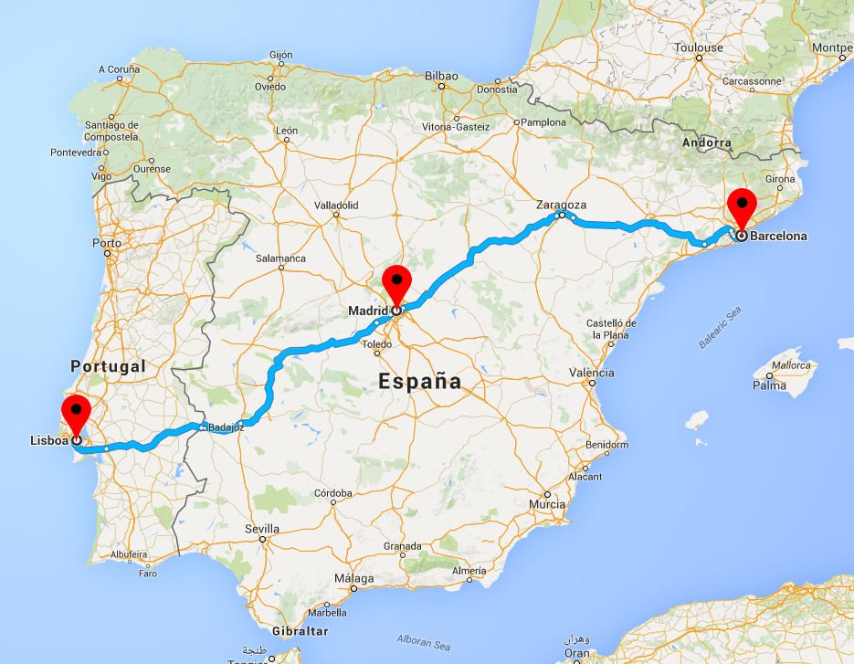

**2n**

**Barcelona**

**1n**

**Lisbon**

**2n**

**Madrid**